**Github Desktop**

1. Install Github Desktop <https://desktop.github.com/> (Note do not do with over the @memorial-guest wifi as this may cause problems)

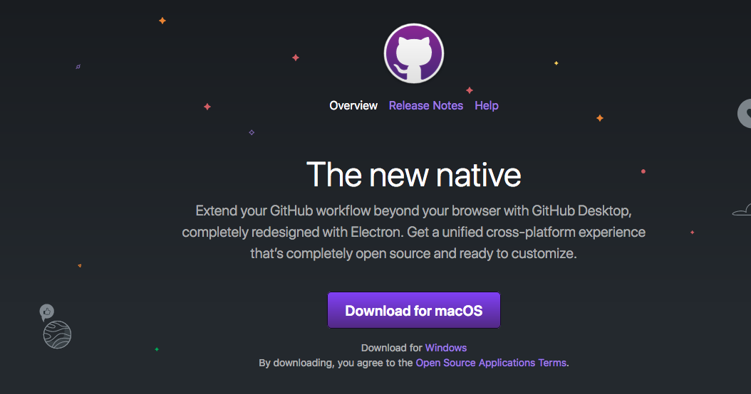

1. Go to the class git repository <https://github.com/ahurford/BIOL-3295>
2. Click on the green **‘Clone or download’** button

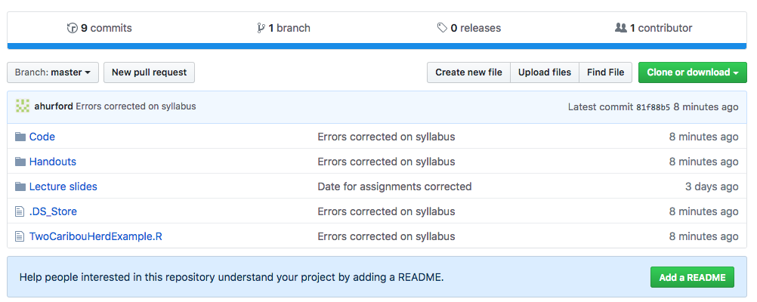

1. Click the left option **‘Open in Desktop’** (if you have not installed Github Desktop as per step 1, then see * below).

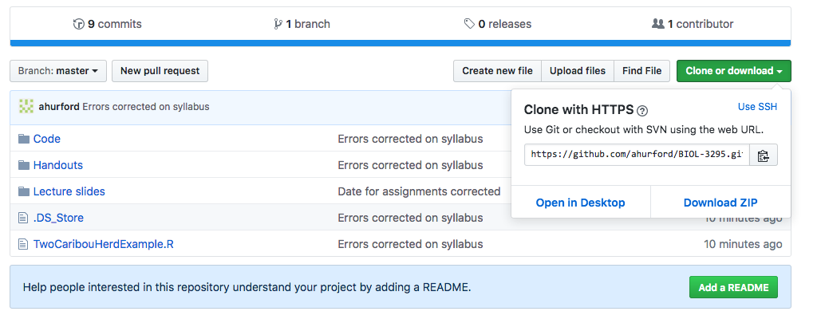

1. My computer then gives a ‘Launch in Application’ window and I select ‘GitHub Desktop’ and ‘Open link’, but you may get something different depending on your computer.
2. My Github Desktop now displays the following screen:

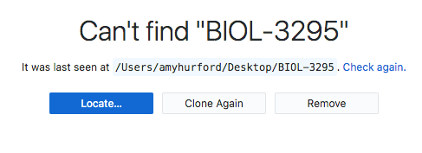

This is because I deleted my BIOL-3295 folder for the purpose of this example. If you haven’t downloaded before you’ll likely have a different screen.

* “Locate…” means the software suspects that I may have moved the “BIOL-3295” folder from my Desktop (where this folder was last seen), and asks if I would like to guide it to the new directory where I moved it. In my case I put the file in the trash so I could recreate a more realistic help file, so it won’t help to provide a location.
* **“Clone Again”** is the option I will choose. This will copy all the folders from the Github repository to a folder on my Desktop (I believe I had previously specified Desktop as the location that I wanted these files to appear in).

1. After I click **“Clone Again”** a folder “BIOL-3295” appears on my Desktop and this folder contains all the latest files for the class.

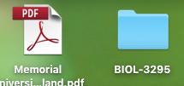

1. The usefulness of this will become apparent later, as it is very easy to get the most recent course material using Github Desktop. With the current repository selected as “BIOL-3295” and the Current Branch as “master”, click on **“Fetch origin”** and any new files will be downloaded to your BIOL-3295 folder.

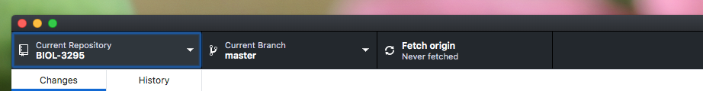

1. The final step is to link your Github account to your Github Desktop. Sign-up for Github here: <https://github.com/join>. Next in the **“Github Desktop”** menu, select **“Preferences”**.

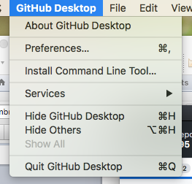

1. Next, you want to sign in to your github.com account using your newly created credentials:

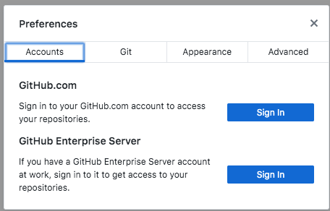

I’m not certain that at this stage of the class, this is necessary, but for Labs 5 and 8 you will need to submit your own files to the class repository, and you will need to be logged in for this.

**When you make changes to your local files**

You might add notes to your local copy of the lecture slides, or you might edit and R script while working on a lab. This may cause conflicts as the version of the files on the remote server doesn’t match your local version.

**Git**

If Github Desktop isn’t work